SUCCESS INTEGRATED NURSERY SCHOOL
Internal End of First Term Examinations 2020
Literacy 4-5 years

Name ________________________Stream__________
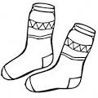
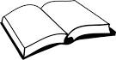
1. Match the belongings.

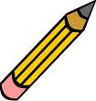
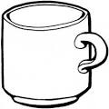
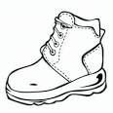
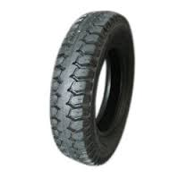
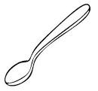


2. Read and draw.
baby | sister | father | mother

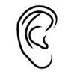
3. Name these body parts.
ears mouth
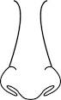
_____________ tongue


_____________ ears

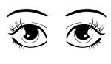
_____________ nose

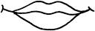
______________ eyes

4. Draw and write.
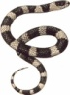  snake | 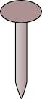  nail | 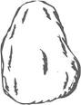  stone | 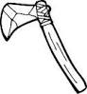  axe

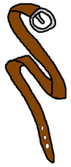
5. Match pictures to words.
tie
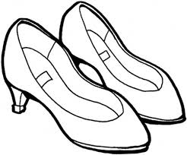
hat

belt
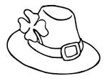
shoes
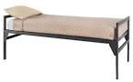
6. Circle the same.

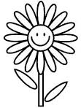
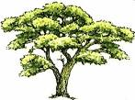

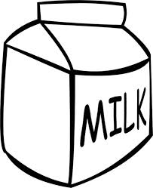
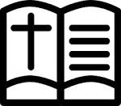

7. Shade these fruits.

